Setup Guide to AWAS

1. Download the newest Eclipse Classic from <http://www.eclipse.org/downloads/>
2. Run Eclipse and go to the menu item Help->Install New Software…
3. Use the dropdown box to select your release version of eclipse, type in “subversive”, and select the checkbox that says “Subversive SVN Team Provider”

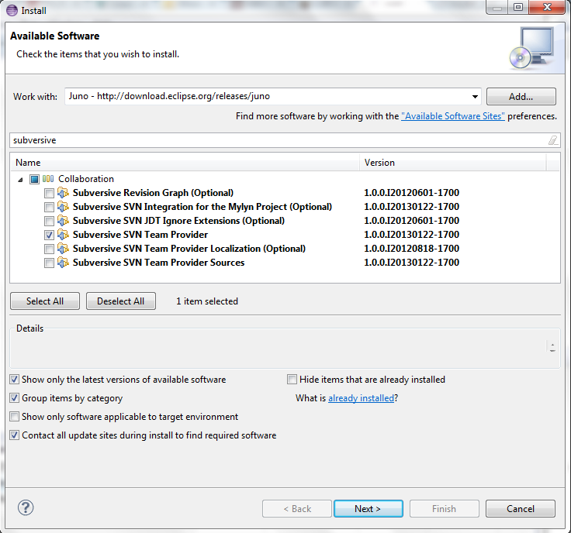

1. Click Next and complete the Installation process for this.
2. Eclipse will restart and ask you to install more items. Select SVN Kit 1.7.8

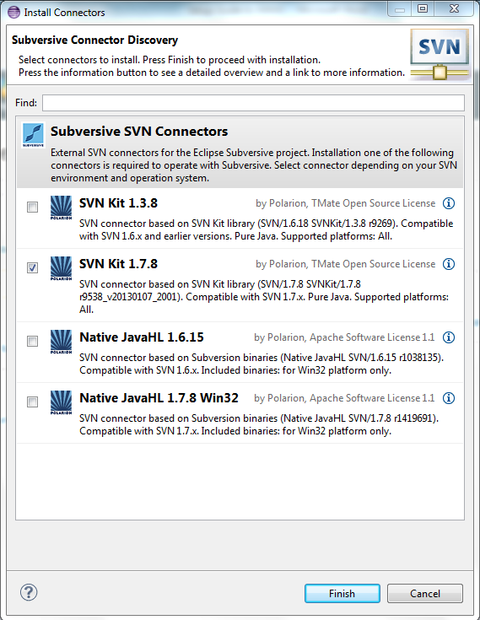

1. Use the defaults throughout the rest of this installation process. Eclipse will again restart after this process finishes.
2. Next click File->New->Project

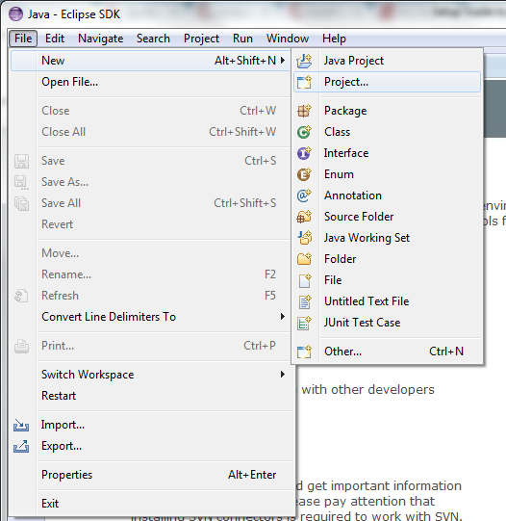

1. Select SVN->Project from SVN and click Next

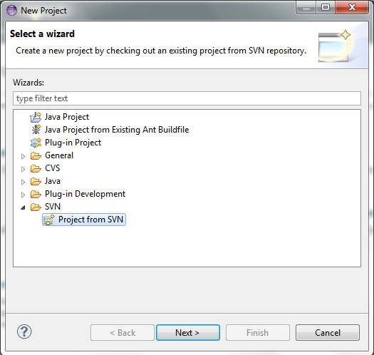

1. Next type in the url <https://awas-automated-web-app-scanner.googlecode.com/svn/trunk/AWAS> , your username, and your password. If you do not have a username and password yet you will need to be added to the project on Google Code. Otherwise your info should be available at <https://code.google.com/p/awas-automated-web-app-scanner/source/checkout>

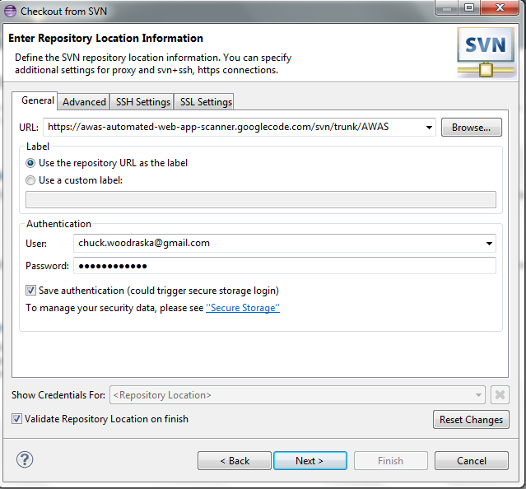



1. Finish the rest of the checkout process by using defaults throughout the rest of the process until you click Finish. The AWAS project should now appear in your project viewer named as WebTester0.1 unless you changed the name.
2. Now we have to add libraries to the build path. Right click the project and select Build Path->Add Libraries…

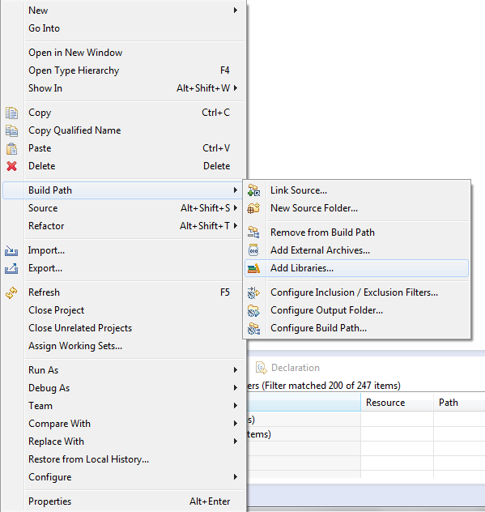

1. Click on User Library and click Next

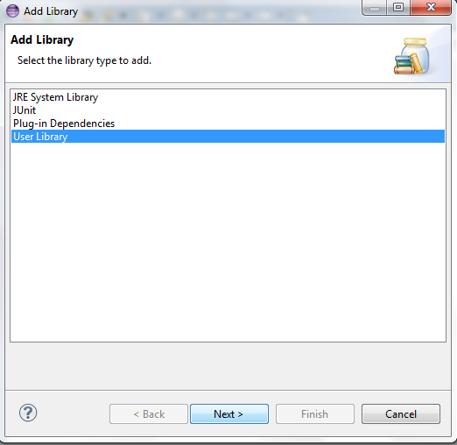

1. Click the User Libraries… button

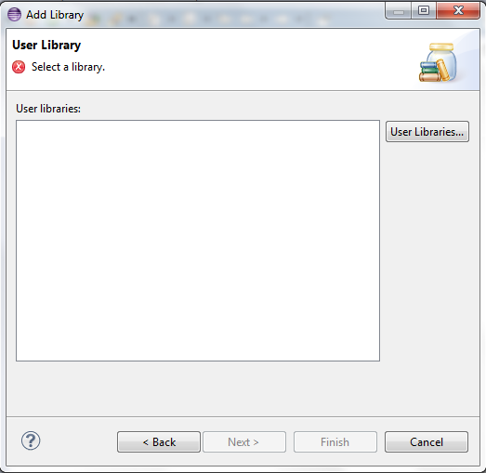

1. Click the New… button and name the library and click OK.

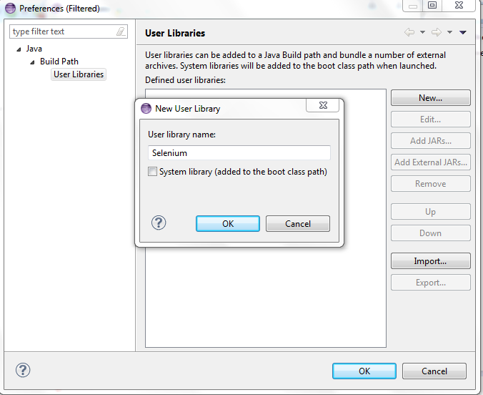

1. Make sure the new library is selected and click the Add External JARs… button. Navigate to wherever the project is located on your computer and go into the Libraries folder and select all the items in that folder.

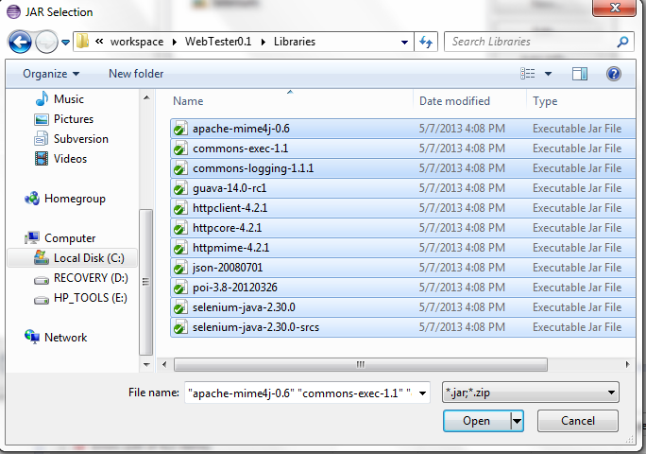

1. After adding the libraries you should be able to run AWAS by opening up the WebTester.java file and clicking Run.

